Goundwire setup for webconnex.
See the last 2 pages for QR codes
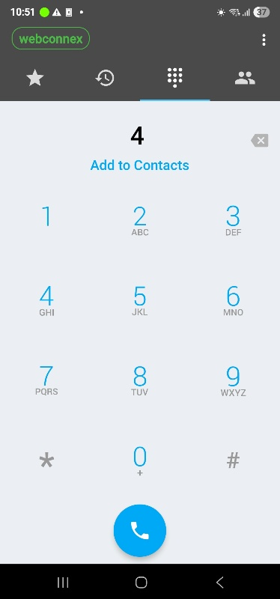 | Tap the menu icon (3 dots, top right)
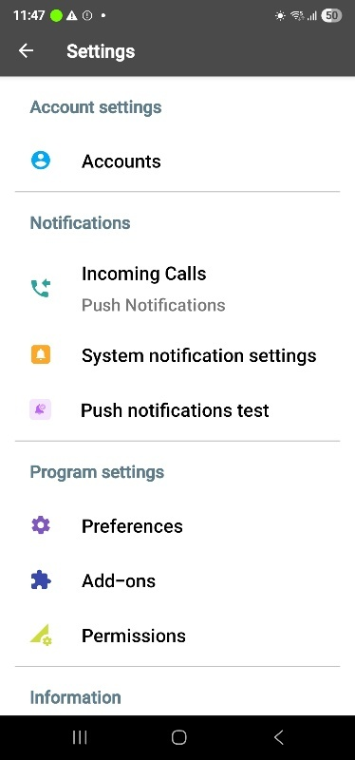 | Under Notifications, tap Incoming Calls and select  Push Notifications.  This is important because it saves battery and allows incoming calls when the phone is asleep.  When done, tap Accounts
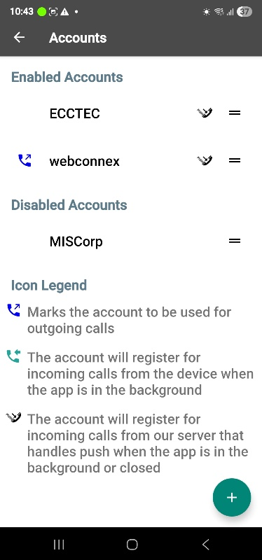 | Tap + to add a new account (bottom right)  In this screenshot I already have the account for webconnex so I would tap that.
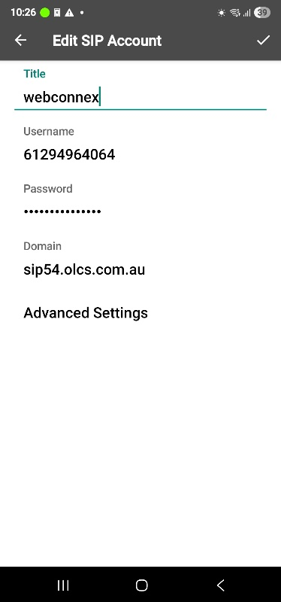 | Give the account a Title  EG. webconnex or Work  Username: (provided by admin)  Password: (provided by admin)  Next, tap Advanced Settings
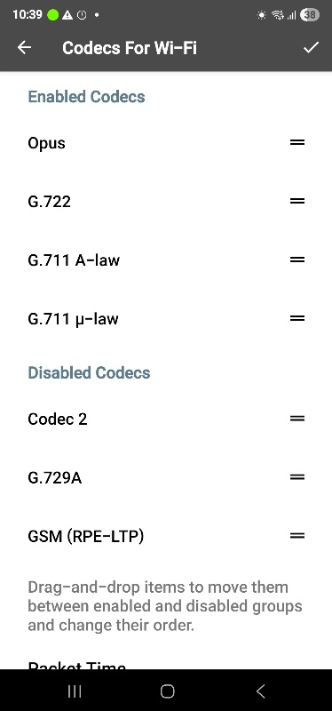 | Tap Codec for Wi-Fi  Set these Codecs  You can drag them around with the handle that looks like =  Tap the back icon when done (Top left)
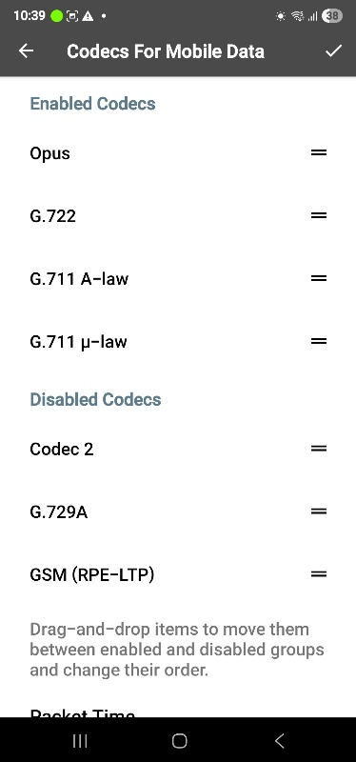 | Tap Codec for Mobile Data  Set these Codecs  You can drag them around with the handle that looks like =  Tap the back icon when done (Top left)
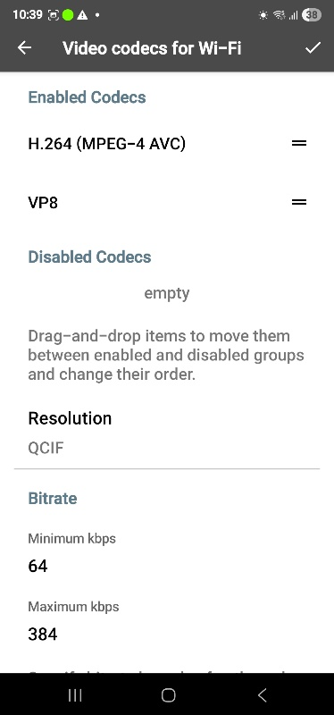 | Tap Video codec for Wi-Fi  Set these Codecs  You can drag them around with the handle that looks like =  Tap the back icon when done (Top left)
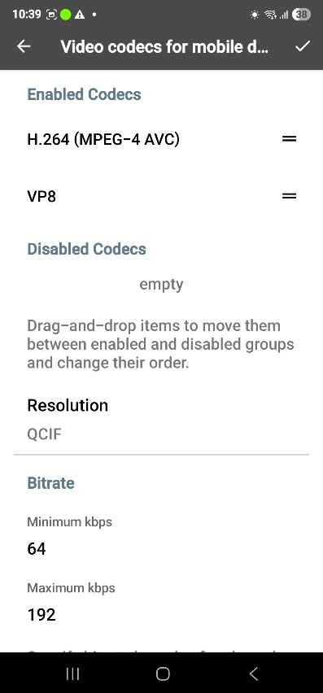 | Tap Video codec for Mobile Data  Set these Codecs  You can drag them around with the handle that looks like =  Tap the back icon when done (Top left)
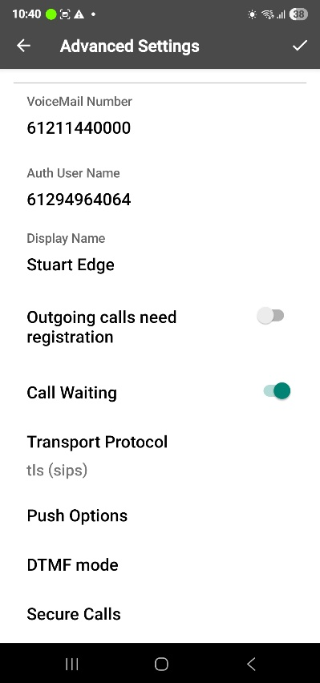 | Swipe up to see these settings  Enable Call Waiting (so you done miss a call)  Set the Transport Protocol to tls (sips)
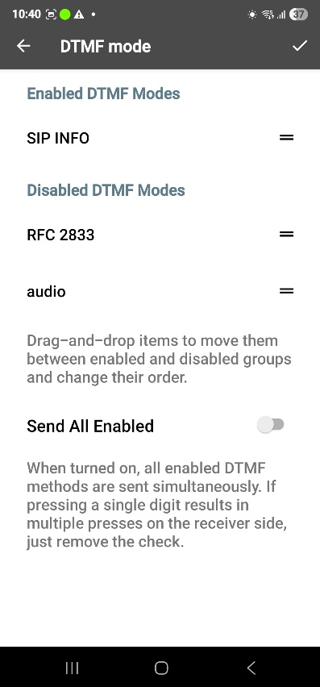 | Tap DTMF Mode  This is used for responding to auto attendant menus (Dial 1 for this, dial 2 for that, etc.)  You can drag them around with the handle that looks like =  Tap the back icon when done (Top left)
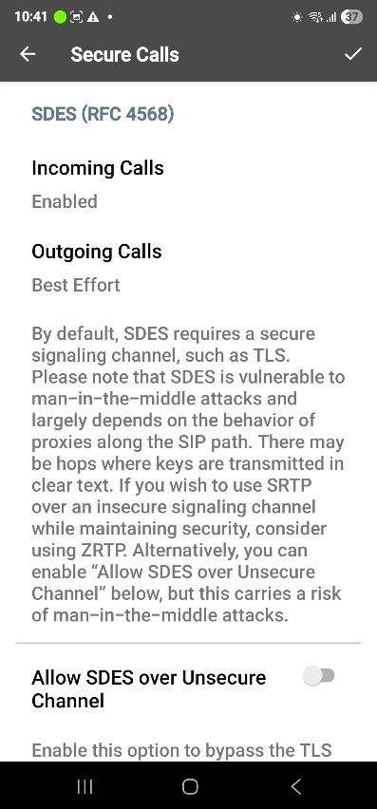 | Tap Secure Calls  Note: External calls are always insecure.  You can enable these for incoming and outgoing  Tap the back icon when done (Top left)
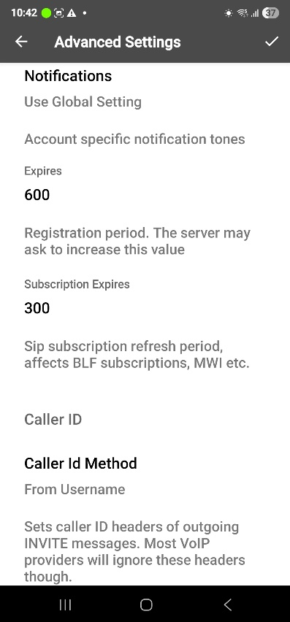 | Under Notifications, set expires to at least 600  Tap the checkmark icon to save the setting when done  (Top right)  Tap the back icon a couple of times to get back to the dial pad.

 | QR code for iPhone

 | QR code for Android app installation.

