# Callout Application

## Purpose

The Callout application ensures that your callers reach important service staff in you organization. Instead of forwarding calls directly to a mobile, you would forward calls to a pilot number.   
EG +61294964056  
This could also be a 1300 or 1800 number. We can provide these services if required this for you.

The callout application will call multiple numbers in a sequence to ensure the that a real person has answered the call. Voicemail and not reachable announcements are ignored so the application will try the next number in the list if one is not reachable.

Each call generates an email with the results of each call. The email can be sent multiple users.

### What is wrong with forwarding call to a mobile?

This application overcomes these problems presented by conventional call groups and call forwarding:

1. Contact’s mobile is unreachable. This would capture the call and play personal voicemail greeting or a carrier message. EG. No battery, no coverage. The call would not proceed to the next number in the list.
2. Contact’s mobile is unanswered. This would capture the call and play a personal voicemail greeting. Once again, the call would not proceed to the next number in the list.
3. Contact’s mobile is busy. This would capture the call and play a personal voicemail greeting. Once again, the call would not proceed to the next number in the list.

### How do we overcome these problems?

To ensure a real person is answering the call not a machine the user is asked to:

* Accept the call by dialling 1
* Reject the call by dialling 0
* If no there is no response the next person in the contact list is called.

## Customisation

This application can be customised depending on your requirements, however, the goal here is to make this user/manager configurable.

In some circumstances, your existing company after hours service or voice menu would handle the initial call and then route to the pilot number for this callout application.

## Web Pages

Each company has a phone number and web site so the application can be customised.  
The web service is designed to work well on a mobile device browser.

This example shows the web site for on-line. Authentication is required.

<https://callout.olcs.com.au/on-line/index.php>

Your company would have a similar URL.

EG. <https://callout.olcs.com.au/yourcompany/index.php>

### Contact page

This page contains the people who will be called and how long each contact will be called.  
Numbers are currently limited to Australia and New Zealand.

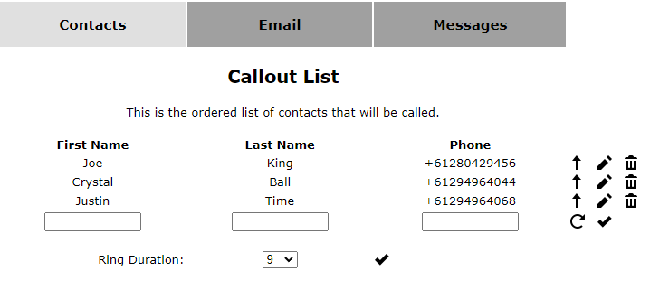

### Email page

This is the list of emails that will receive the alerts regarding the result of each call.

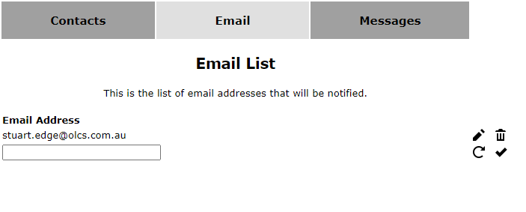

### Messages page

These are the messages that the caller will hear.   
A text to speech engine will convert the text to speech.  
Language and playback speed can be adjusted depending on your preference.

The messages are

1. Initial greeting
2. Message if the caller ID is presented  
   or message if the caller ID is suppressed

