# Make a call

* Type or paste a number in Search / Dial then press Enter
* You don’t have to enter a prefix. EG, 0

# Conversations tab

* Here you can see your call history, if there is a green number, you have missed calls
* Answered outgoing calls will have a green arrow   
  The arrow will be red if a call was not answered  
  The arrow points up for outgoing calls
* A missed incoming call will be red, pointing down  
  and have a number next to the time
* Move you mouse over the time and it will change to a dial icon so you can call the missed party.

# Transfer

* When you are on a call you will have these call controls

Transfer (blind transfer)  
Consultation (to call and ask a question while 1st party waits)  
Tone dial  
Mute  
Hangup

* Select transfer, dial a number, press enter and the call will be transferred immediately

# Conference

* If you make a Consultation call and the 2nd part answers  
  You will see a new Icon to make a Conference call
* Select Consultation, dial a number, press enter and the 2nd call will be made while the 1st party waits on hold
* Select Conference

# Favourites tab

* You can add internal contact by clicking the star
* You will be prompted for a group
* 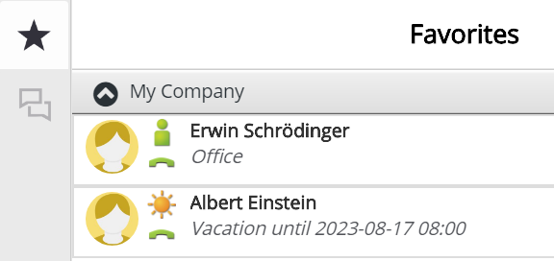Now, in the Favourites tab  
  You will see the Presence Status   
  The green handpiece shows the currentt call status  
  Flashing bell – Ringing  
  Red handpiece – Busy
* If anyone calls Albert, the call will go to voicemail.  
  “Albert is on vacation, returning 17th, etc”

# Presence tab

* Here you can change your own presence setting,
* If you select Office you can enter a call forwarding number (EG, your mobile)
* All other presences settings will request a return time so everyone can be informed of your availability.