**Download and install OpenScape Mobile Pro from Google play**

<https://play.google.com/store/apps/details?id=com.unify.osmo&hl=en_AU&gl=US>



**Display the QR Code that contaians your personal Account Information**

Once the app is installed, a different QR code is provided by Web Client or the UC Desktop App.

1. From Web Client or the Desktop App, click your name, then Profile  
   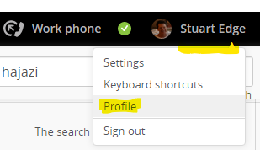
2. Click OS Mobile QR to display your QR code  
   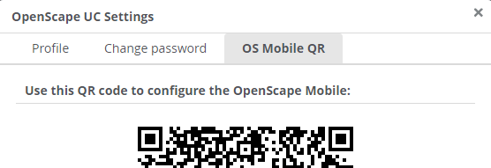

**Account**

Enter your account details in OpenScape Mobile as follows:

1. Select the User Tab  
   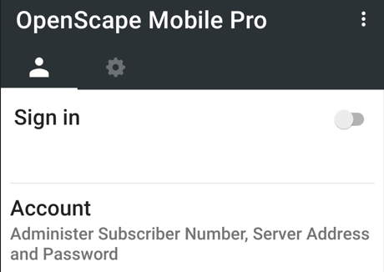
2. Tap Account
3. Tap the Green QR code icon  
   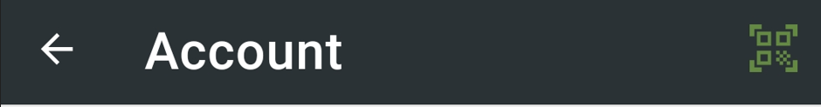
4. Scan the QR code.
5. Enter your password (The same password you use to login to the app).
6. You should get something like this, otherwise you can enter the details manually.

|  |  |
| --- | --- |
| Subscriber | user.name@system |
| Password | Manual entry |
| Remember me | Enabled |
| Cell Number | +6141111111111 |
| Server Address | <https://facade.olcs.com.au:8443/axis/services> |

**Recommended Settings**

1. Select the settings tab  
   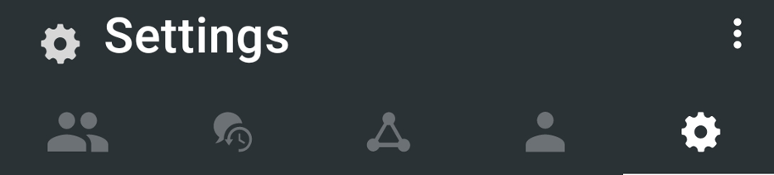
2. Make these settings

|  |  |
| --- | --- |
| Allow VoIP Calls | Enabled |

1. Advanced Settings

|  |  |
| --- | --- |
| Country Specific Tones | Singapore |
| SIP Push Notifications | Enabled |
| Route Calls to Cell | Enabled |
| Allow Invalid Certificates | Enabled |