**Download OpenScape Mobile Pro Install from Google play / App Store**

<https://play.google.com/store/apps/details?id=com.unify.osmo&hl=en_AU&gl=US> [QR Code](https://www.ecctec.com.au/user/User_Guides/OpenScape_Mobile/QR/OSMO.qrcode.android.png)

<https://apps.apple.com/us/developer/unify-software-and-solutions-gmbh-co-kg/id302973846> [QR Code](https://www.ecctec.com.au/user/User_Guides/OpenScape_Mobile/QR/OSMO.qrocode.iphone.png)

**Account**

Enter you account details as follows:

1. Select the User Tab  
   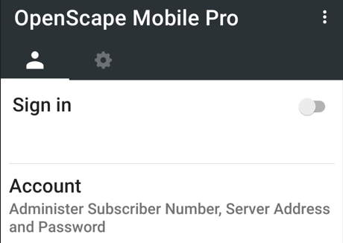
2. Tap Account
3. Tap the Green QR code icon  
   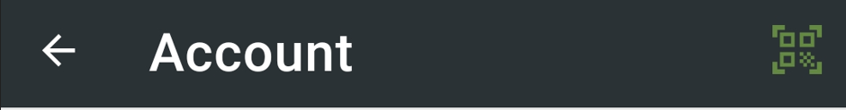
4. Scan the QR code.  
   You should get something like this, otherwise you can enter the details manually.

|  |  |
| --- | --- |
| Subscriber | Provided by vendor |
| Password | Provided by vendor |
| Remember me | Enabled |
| 203.23.175 | +61411111111 (your phone’s mobile number) |
| Server Address | sbc-subscriber-dc2.olcs.com.au:65061 |

**Recommended Settings**

1. Select the settings tab  
   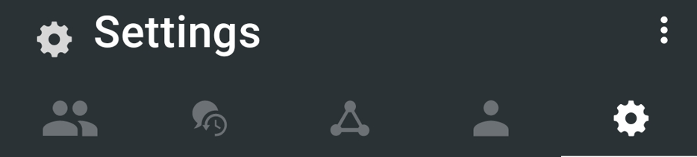
2. Make these settings

|  |  |
| --- | --- |
| Allow VoIP Calls | Enabled |
| SIP Push Notifications | Enabled |

1. Permissions

|  |  |
| --- | --- |
| Phone State | Enabled |
| Microphone | Enabled |
| Location | Enabled |
| Camera | Enabled |
| Contacts | Enabled |
| Draw over other apps | Enabled |

1. Advanced Settings

|  |  |
| --- | --- |
| Country Specific Tones | Singapore |
| SIP Push Notifications | Enabled |
| Route Calls to Cell | Enabled |
| Allow Invalid Certificates | Enabled |

1. 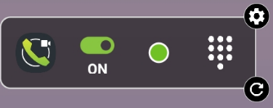With Android you can add a widget on the home screen