## **Connect your OpenScape CP to your OpenScape UC Account**

This applies to OpenScape Desk Phone models CP400, CP600E, CP700, CP700X

1. Press the Hamburger Menu (three horizontal lines)
2. Select Settings
3. Select User Settings
4. You may need a password (Maybe 123456)
5. Scroll down to Network information and select
6. Note IPv4 address (EG. 192.168.10.40)

Now use a web browser to access you phone

1. <https://IPv4Adress>  
   EG. <https://192.168.10.40>  
   Choose Advanced and proceed to the web page (It’s safe, it’s you phone)
2. Enter you user password
3. Click Configuration
4. OpenScape UC
5. Enter your UC user data

|  |  |
| --- | --- |
| Server | https://uc.olcs.com.au:8443 |
| Username | +61294964000@system |
| Password | ********* |

1. Click Submit
2. Your phone will now synchronise with your OpenScape UC Account

You may wish to program some Selected Dialling keys.  
If an internal contact has allowed you to see their presence, you will see this next to the key on your phone.

Using a web browser as above from point 2

1. 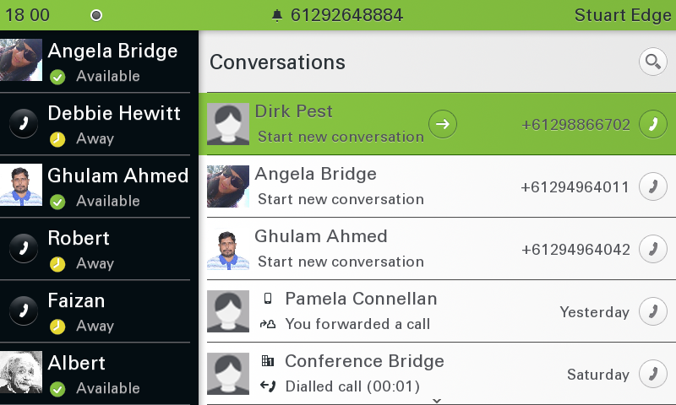Click Phone
2. Click Permanent favourites
3. Choose a key
4. Select Selected Dialling
5. Click Edit
6. Enter a Label (Name)
7. Enter a number is e164 format   
   EG. +61294964040
8. Click submit

Now the Favourites key will light Green, Yellow or Red, depending on the contact’s presence setting.