OpenScape UC

Web Client User Guide

Contents

Audio and Video settings 2

Other settings 2

Voicemail settings 3

Tabs 3

Making calls 4

Call back 4

Incoming calls 5

Call controls 5

Transfer a call (announced) 6

Transfer a call (blind transfer) 7

Voicemail 8

Hunt Groups 9

Conferences 10

Microsoft Teams Integration 13

Update Microsoft Teams Integration 13

Screen Sharing 14

Remote Control 17

Logging in

1. Open your Chrome browser [https://uc-fe1.olcs.com.au:8443/openscapeuc/](https://uc.olcs.com.au:8443/openscapeuc/)  
   If chrome is your default browser, click the link above  
   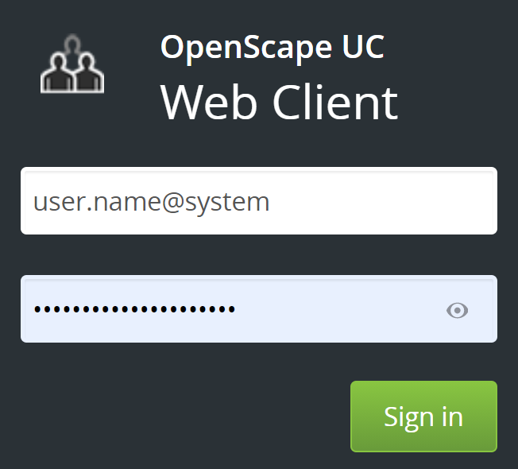
2. Sign in if you have your login credentials.

## Audio and Video settings

If you are connecting using a USB / Bluetooth headset or a conference device you have to select which device you want to use.

1. Click on your name and select **Settings**
2. In **Audio output** select the device for call audio (usually your headset)
3. In **Ringing output** select the incoming ring sound (usually your PC Speaker)
4. In **Microphone** select the device for microphone (usually your headset)
5. In Camera select your preferred camera (EG. Front, back or conference room camera)

## Other settings

Other useful settings:

1. In the Presence tab you can select **My presence status during login/logout**
2. In the **Devices** tab you can choose which device you want to use for each presence option  
   EG
   1. Available Work phone
   2. Away Mobile phone
   3. Be right back OpenScape Mobile

## Voicemail settings

1. Click on your name and select **Settings**  
   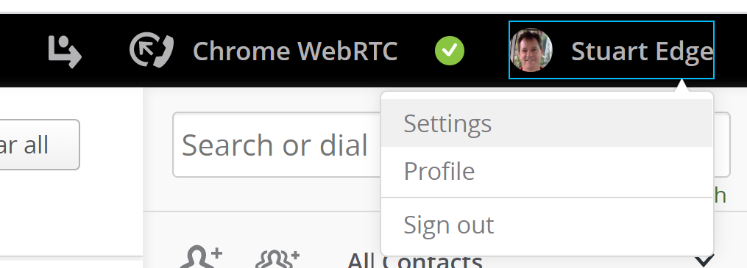
2. Switch to the voicemail tab  
   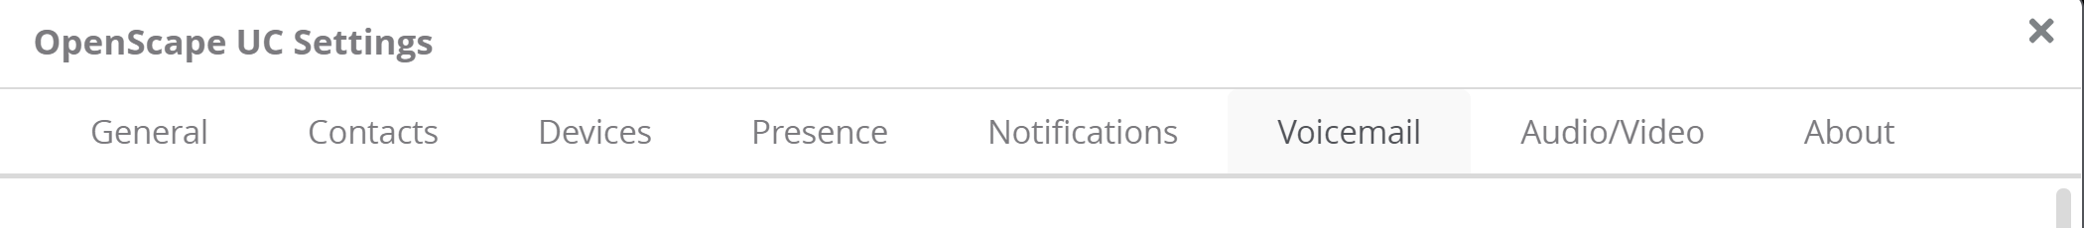
3. You can choose from a number of greeting types; Single greeting is the easiest.
4. Click settings to expand
5. Click the Microphone icon to start and stop recording  
   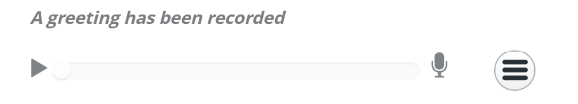  
   You can listen to the recording with the play button
6. Scroll down to bottom of the page to **Recording of name**Record your name (this is not a greeting, just a name)

## Tabs

The following tabs are displayed on the left side of the browser window  
 The tabs (top to bottom) select the following pages

* Call history
* Conferences
* Voicemail
* Chats

## Making calls

* Search for or dial a number or contact in the search bar.   
  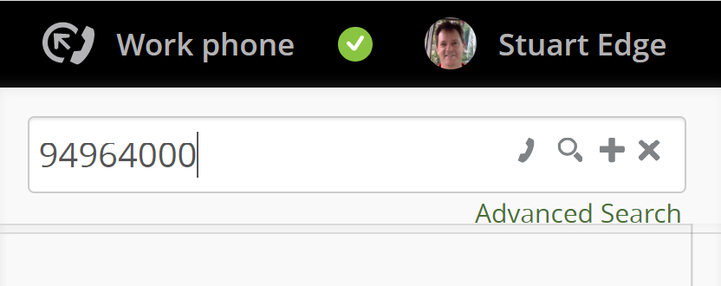

or  
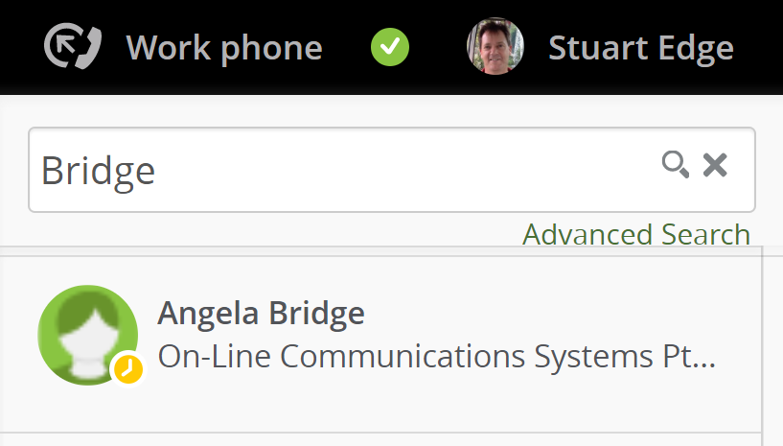

* **Press enter to complete dial or search  
  You can also click one of the icons in the Search or dial bar.**
* Hover your mouse over the call history and click the dial icon
* Click a telephone number link in any application (may require OpenScape Fusion for MS office)  
  Here is an example of a tel link: [Main Office:       +61 2 9496-4000](tel:+61294964000/)  
  When you hover your mouse over it you will see <tel:+6129496400>0/
* OpenScape will accept many number formats such as:
  1. International with plus +61294964000
  2. International without plus 61294964000
  3. International with prefix 001161294964000
  4. National 0294964000
  5. Local 94964000
  6. Extension 4000  
     Your extension numbers can be setup with 1, 2, 3, 4 or more digits

## Call back

* If an internal user is busy or does not answer, you can request a callback  
  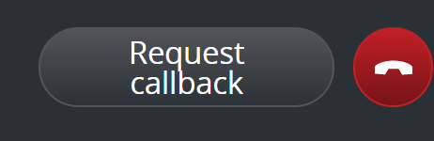
* When the user you want to reach is available, the system will call you. When you answer the callback, their number will be dialed immediately.

## Incoming calls

1. When a new call arrives on your web service you will see this:  
   
   1. The first icon allows you to switch the call to another device
   2. The second icon allows you to deflect the call to another number
   3. The GREEN icon will answer the call
   4. The RED icon will reject the call – usually to voicemail.

## Call controls

* When you are on a web call you will see these icons  
  
* These icons (left to right) are:
  + Screen Share
  + Hold
  + Mute Microphone
  + Video
* Phone calls do not support video but they can support screen sharing if both ends have the web client running

## Transfer a call (announced)

1. While on the phone to a contact, click the contact icon to search and/or dial another contact  
   This will automatically place the 1st contact on hold
2. Speak to the 2nd contact
3. From the menu below, select transfer to waiting call  
   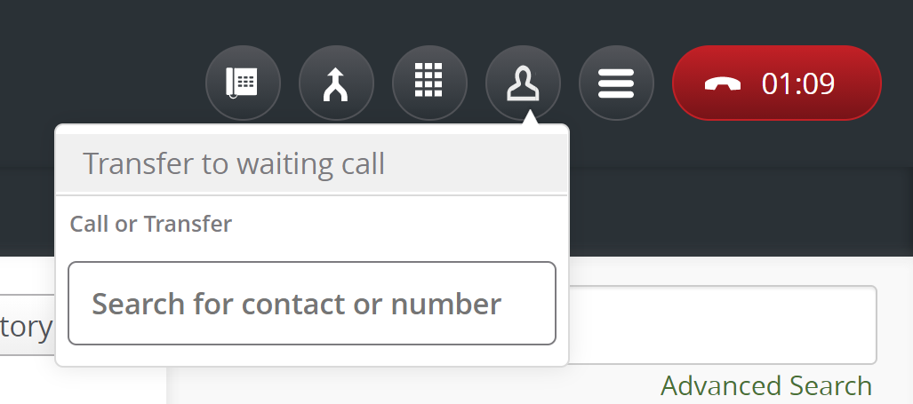
4. If the 2nd contact does not wish to take the call or does not answer, click the **red hang-up icon** and you will be reconnected 1st contact  
   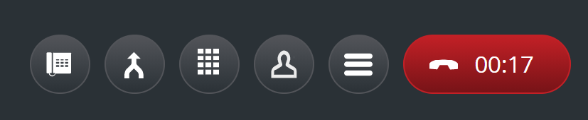
5. If the 2nd contact hangs up before you do, the second call will remain on hold  
   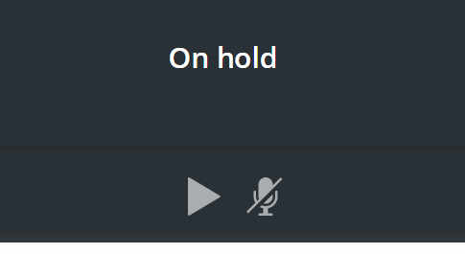  
   Click the PLAY Icon to reconnect.

## Transfer a call (blind transfer)

1. While on the phone searched or dial another contact  
   Here I have search for “test”  
   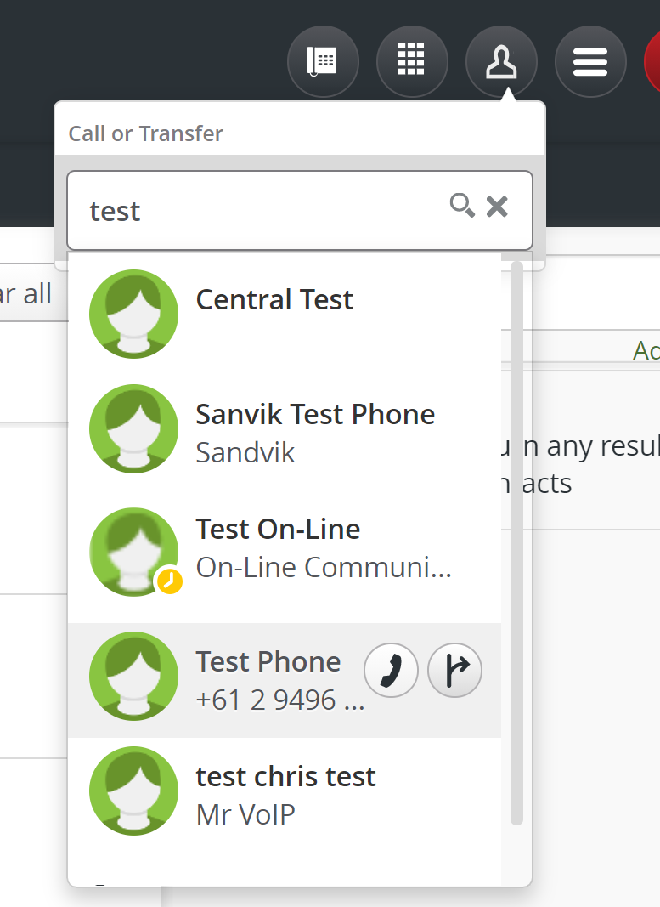
2. Click the transfer icon to transfer the call immediately.

## Voicemail

If you miss a call, you will see the missed call in the Call history tab

* You can hover your mouse over this to see call controls  
  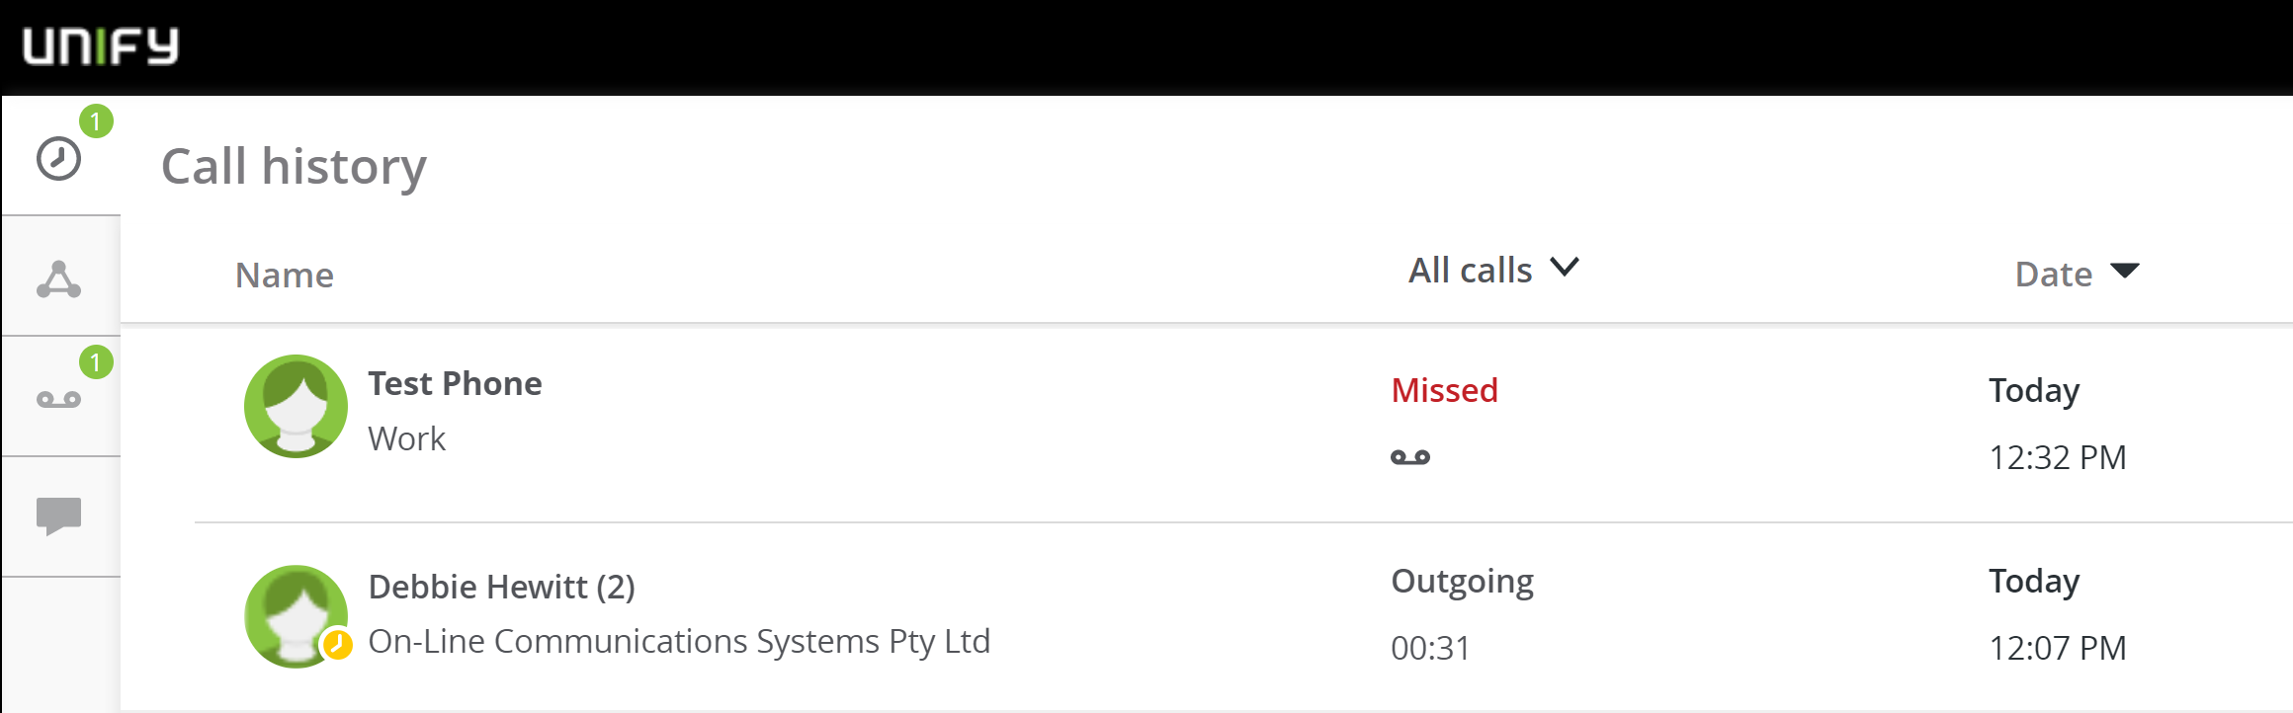
* If you click the voicemail tab on the left, you will see this  
  Here you can play the message and call the person who left the message.  
  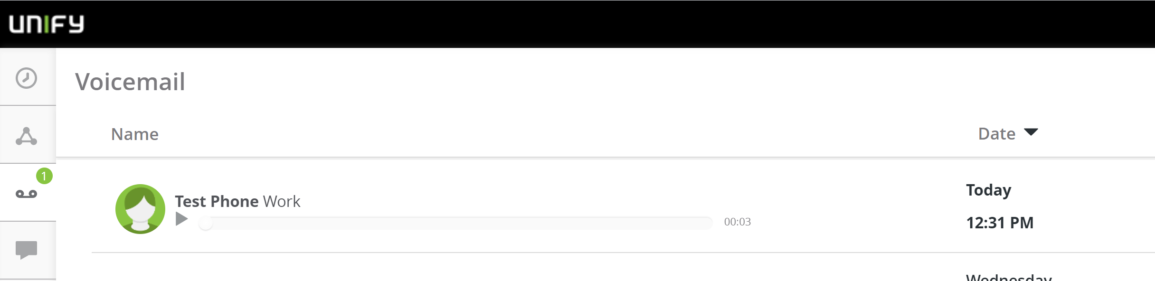
* If you have a desk phone the message key may illuminate to indicate a new message.
* You can also have a notification sent via SMS or email.

## Hunt Groups

Hunt Groups are used to distribute incoming calls to a predefined group of users.  
A hunt group has its own number – the pilot number. This is often the main company number or a service department, etc.

A hunt group can distribute calls depending on your requirements.

* ***Simultaneous*** – All phones ring
* ***Linear*** – Always tries the first in the list
* ***Cyclic*** –Shares calls circular fashion

These options apply for ***Linear*** and ***Circular*** hunt group patterns

* + If the first person doesn’t answer or is busy, the group will ***hunt*** for next person
  + If everyone is busy, calls will wait in a queue

Usage:

* If your extension number is part of a hunt group you will see this icon  
  
* If you click on the icon, you will see this menu  
  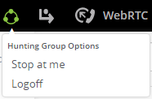
* If you select **Logoff** the icon will go grey.  
  
  + You won’t get calls via the hunt group
  + You can still get calls via your direct number
  + New calls will hunt to other group members
* If you select **Stop at me**  
  
  + You will get calls via the hunt group
  + You can still get calls via your direct number
  + New calls won’t hunt to other group members, they will queue
* If you select **Logoff** while **Stop at me** is active  
  
  + You won’t get calls via the hunt group
  + You can still get calls via your direct number
  + New calls won’t hunt to other group members
  + If you are the first member of a linear hunt group, calls may be directed to an announcement, voicemail, an after-hours number or busy tone
* If all hunt group members are logged off, calls may be directed to an announcement, voicemail, an after-hours number or busy tone

## Conferences

If you have the conference option, you can create ***Scheduled*** and ***Persistent*** conferences.

* To Create a new scheduled conference, click **New Conference**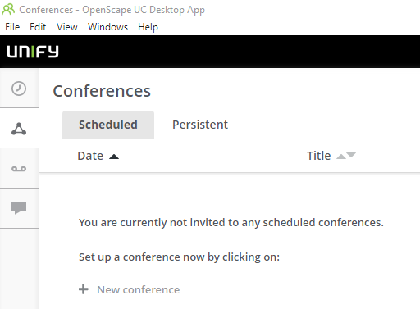
* Other OpenScape users within your organisation, if added, will be notified by the system.  
  If call out is selected, they will be called automatically  
  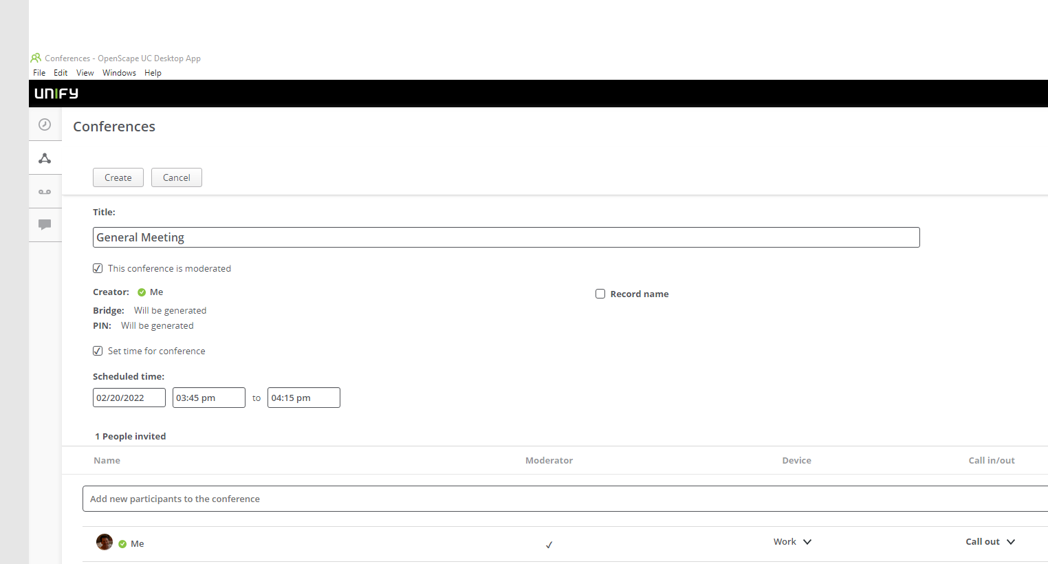

Select **Call Out** if you have opted to be the moderator of a **Scheduled** conference.

* When internal OpenScape users are called, they will be asked to press one to join.  
  Select the dial-pad icon and click 1  
  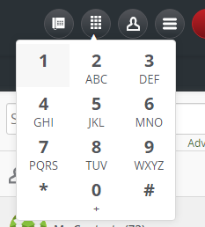
* External parties can be added, however, they must be in your address book.  
  Alternatively, you can just add yourself and create a meeting invitation with outlook  
  This email is automatically sent after you click Create (above)  
  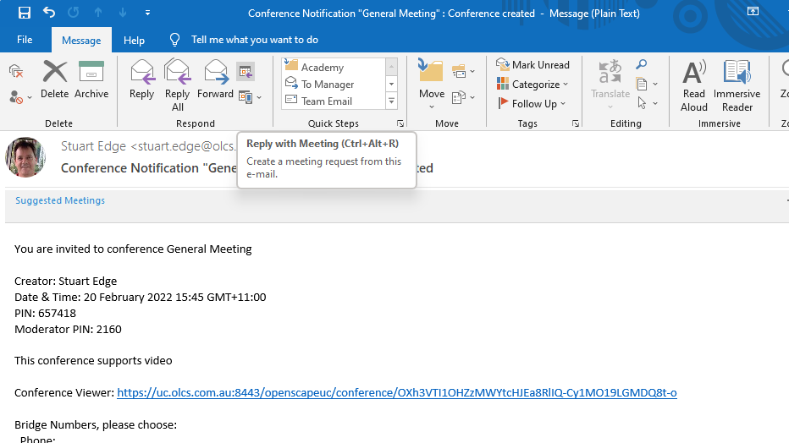
* *External parties must have a web browser with WebRTC capability. EG. Google Chrome, Microsoft Edge Chromium or Firefox (the underlying operating system doesn’t matter)*The link in the email will open this page: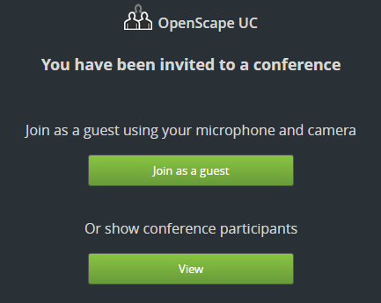
* If they click **Join as a guest,** they will see this screen.  
  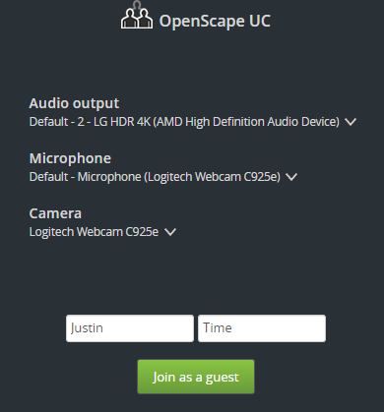  
  Here they can choose various devices available on their local machine
* Once Joined the user can Screen Share, Mute, or Show their video with these icons  
  
* The moderator can record a conference which will be sent via email.  
  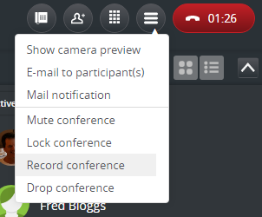
* When the conference is being recorded, all participants will see the recording Icon.  
  
* If you want to create a link for external parties to join, select Mail notification  
  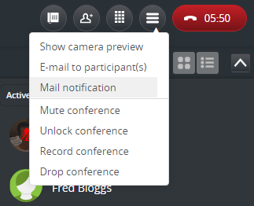
* This will create a link with unique URL  
  This can be sent via email, chat, etc., so someone can join.

To join in this conference as a Guest:   
[https://uc-fe1.olcs.com.au:8443/openscapeuc/conference/Nyt2eHJlbTjdkgjbkldjkljer0eguLTlVVQ2bxbg5U49uW11U](https://uc.olcs.com.au:8443/openscapeuc/conference/Nyt2eHJlbTjdkgjbkldjkljer0eguLTlVVQ2bxbg5U49uW11U)

* Other menu options include:
  + Lock / Unlock
  + Mute / Un-mute
  + Record /Pause /Resume
  + Drop

## Microsoft Teams Integration

Your MS teams administrator can set up the integration for all users.  
The following instructions allow a user the setup of MS Teams nitration as a user.

* To setup Microsoft Teams integrations go to the settings page by clicking your name.  
  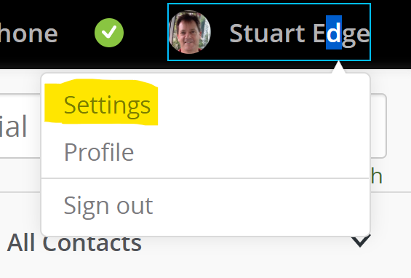
* When the page opens you will see a link “Download the MS Teams Integration”.
* This will download a file called os-msteams.zip
* Open your Microsoft Teams application and navigate to the applications tab.
* In the applications tab, click on the option to upload a custom app, and select the os-msteams.zip integration file downloaded from UC.  
  **INFO**: Depending on your permissions you can either upload the integration file for your team or your personal client only.
* Open the OpenScape UC application that should now be available in the applications menu in Microsoft Teams.
* In the new window click **Add** under the OpenScape UC icon.

After completing the steps above, the OpenScape UC application should appear in the left menu panel of Microsoft Teams.

## Update Microsoft Teams Integration

If a new version is available download the zip file as above.

* Navigate to the Apps section, located on the lower part of the left bar, in Microsoft Teams interface.
* Locate the OpenScape UC application among the list of all other applications.
* Click on the three dots button located on the top left corner of the UC Application icon and select Update.
* In the browser window select the installation file from your computer and click Open.

The application is now updated.

## Screen Sharing

While on a phone call you can choose to share your screen to discuss the content you have on your screen.

1. Click the **Start Screen share** icon to start screen sharing  
   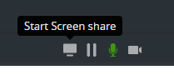
2. A window will pop open giving you the options to share a screen or a particular application window. Scroll down to see more applications.  
   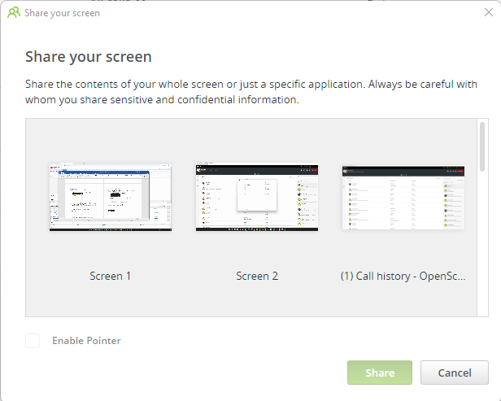
3. If you select an entire screen (in this case **Screen 1** or **Screen 2**) the **Enable Pointer** is available.  
   *If a web user (EG Chrome) is sharing their screen, the pointer and remote-control options are unavailable.  
   However, if a Web (Chrome) user is the recipient of a screen share from OpenScape UC Desktop App, pointer and remote-control options are available.*

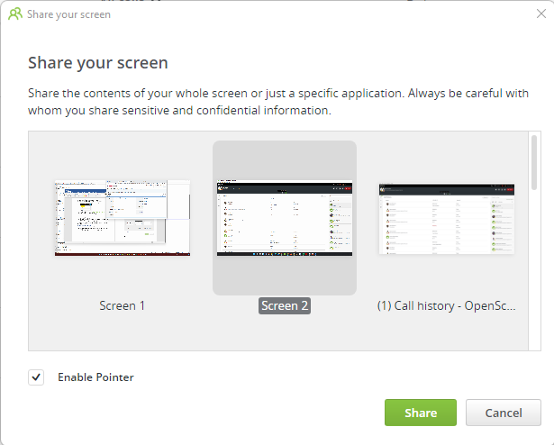

1. When you are screen sharing, this dialog will appear.  
   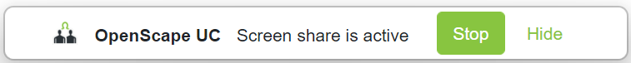
2. Once the screen is shared, if the remote user wishes to point at a particular item, you will see a pointer similar to this.  
   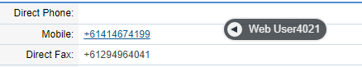  
   This is a great way to guide someone’s attention to a particular item
3. If the party you want to share with is an external party, you can share a link via email.  
   Click on the menu and choose **Notification e-mail**.  
   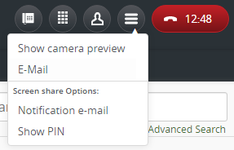
4. This will create a new email with a link to the screen share.  
   If the external party’s phone number is matched to one in your directory and there is an email address, the email address will be automatically added.  
   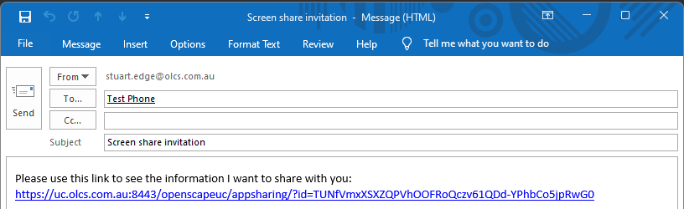
5. The email contains a unique link to the screen share.  
   When your contact opens the link, they will be asked for a PIN.  
   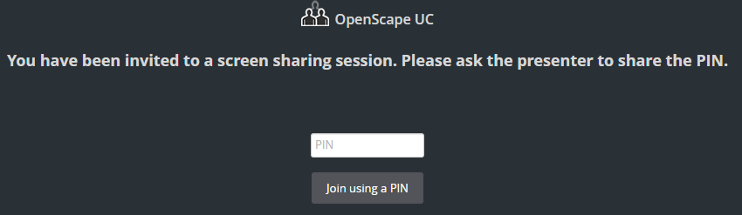  
   The PIN is not included in the e-mail. You must provide the PIN over the phone. This ensures that third parties cannot join if they have seen contents of the email.  
   Click **Show PIN** to see the details and provide the information to the contact.  
   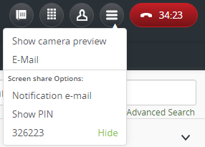

## Remote Control

If the person using OpenScape UC Desktop App is sharing their screen, you have the additional option of remote-control.

1. If someone is sharing their screen with you, you have options to choose full screen or zoom in with this control. (Top left)  
   
2. You can also request to control the remote user’s machine by clicking this (bottom left)  
   
3. The remote user can Allow or Decline the request for remote control   
   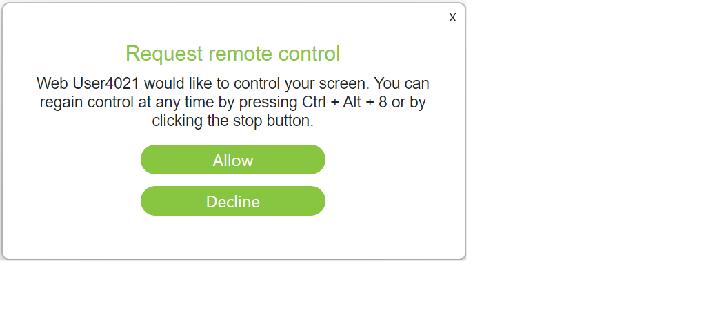
4. Once you have remote control, the icon will turn green



1. If you are screen sharing and someone has remote control, you will see this in the OpenScape UC Desktop App  
     
   The **Red** icon on the right allows you to stop remote control.  
   The **Green** icon on the left allows you to stop screen sharing and therefore remote control.
2. You can screen share and video call at the same time (Camera item second from right)