**Windows Sound Devices**

Windows has two types of sound devices:

* Output (Speakers)
* Input (Microphones)

These can be setup as:

* **Default Device**  
  General Windows Sounds and Microphone
* **Default Communications Device**  
  For Communication Programs like OpenScape UC or Microsoft Teams
* If the **Default Communication** device is not available, Windows will fallback to the **Default** device

**Windows 10 or 11**

1. Open Windows Control Panel
2. Double Click **Sounds**  
   This will open the **Playback** tab  
   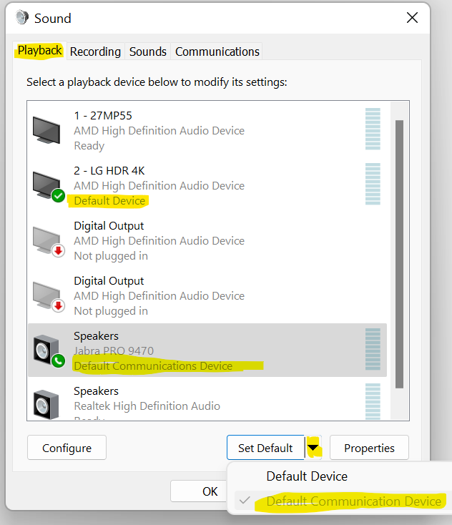  
   *In this case, I have previously selected the Jabra PRO Headset (so it’s greyed)*
3. Select the **Recording** tab  
   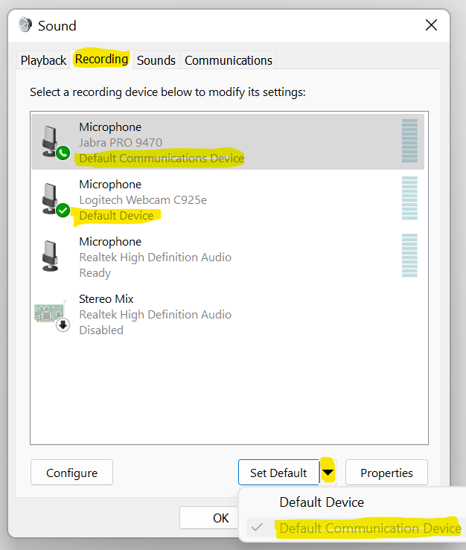  
   *In this case, I have previously selected the Jabra PRO Headset (so it’s greyed)*
4. Select the **Communications** tab  
   Here you can select what happens to other sounds while you are using your **communications** device. 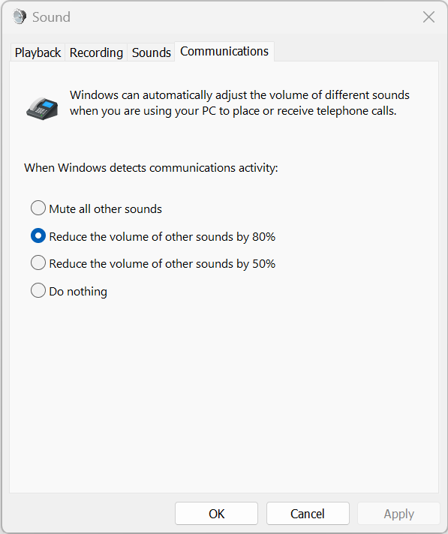

**OpenScape UC Settings**

1. In **OpenScape UC Web** or **Desktop App**, top right, Click ***Your Name***
2. Click **Settings**
3. Select the **Audio/Video** Tab  
   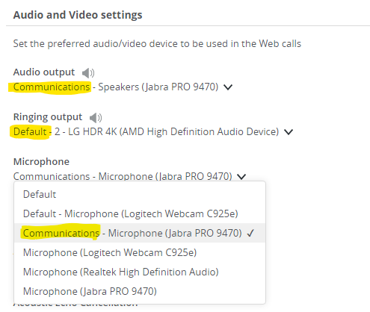  
   *Here I have selected* ***Communication*** *for* ***Audio output*** *and* ***Microphone****.  
   The* ***Ringing output*** *is my* ***Default*** *device, the Speakers in my LG 4K screen.   
   This is selected so I can hear incoming call alerts (ringing) without having to wear my headset.*