SignageConnex Overview Guide

[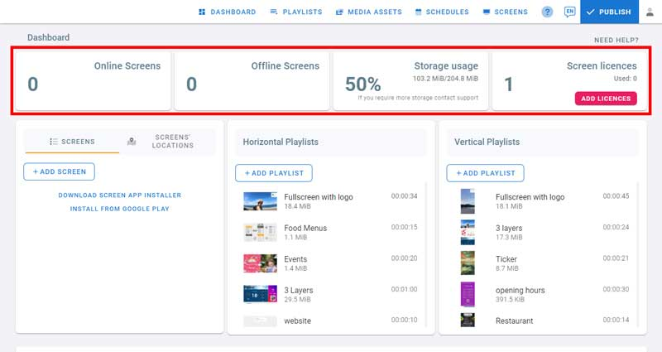](https://help.easysignage.com/assets/img/dashboard/dashboard-1.jpg)1- System Statistics

On the first row, we have the system statistics.

* The statistics include online screens, offline screens, the storage usage for this account, and the licences available for this account.

[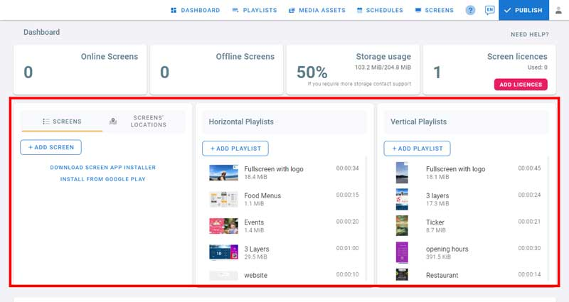](https://help.easysignage.com/assets/img/dashboard/dashboard-2.jpg)

2- Screens and Playlists

On the second row we have 3 sections: The first is for screens, the second and the third section is for horizontal and vertical playlists.

[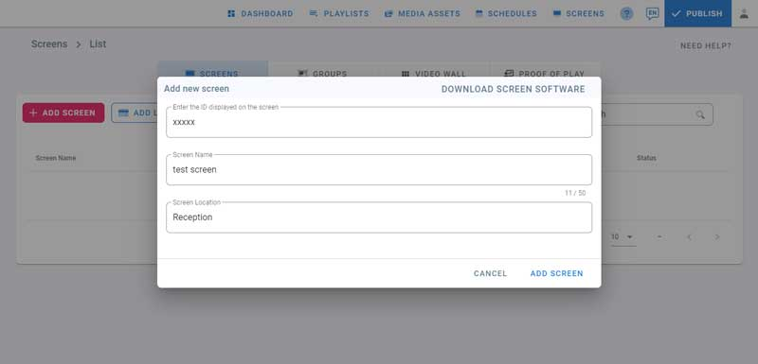](https://help.easysignage.com/assets/img/dashboard/add-screen.jpg)**Screens**

* Click on **Add Screen**. This will open the dialog where you enter the code you see on the screen.
* [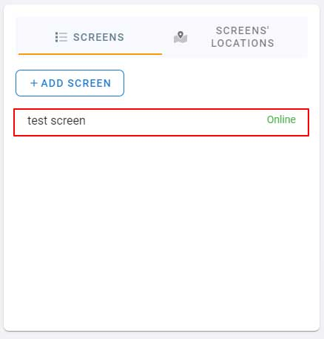](https://help.easysignage.com/assets/img/dashboard/add-screen-2.jpg)Get the code from the screen and enter it.
* Enter the screen name and location then click on **Add screen**.
* Now go back to the dashboard.
* You can see the screen we just added.
* Click on screen’s location to check its location on the map.
* Below the screens section, you can check Screens’ Status History on this bar chart.

**Playlists**

* [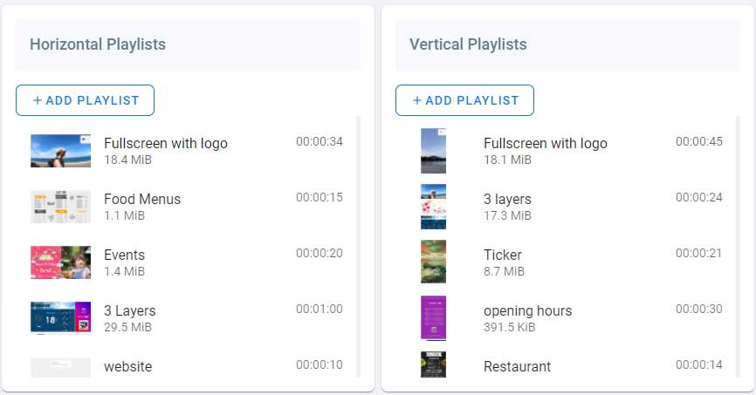](https://help.easysignage.com/assets/img/dashboard/dashboard-playlist.jpg)In the playlists section, You can see your horizontal and vertical playlists here.
* You can add playlists by clicking on **Add Playlist**.
* Default playlists and playlists you create will be listed here.
* To open a playlist click on it. It will open the playlist where you can start adding content.

Playlist Management

* Click on playlists in the navigation bar
* There are three types of playlists, horizontal playlists to be used in landscape screens, vertical playlists to be used in portrait screens, and video wall playlists.
* Preset Playlists are created by default with different layouts and media types.

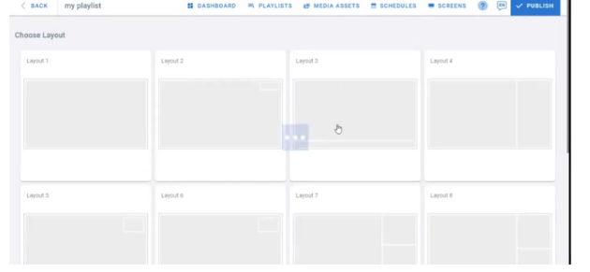Add Playlist

To add a new playlist

* Click on **Add Playlist**
* Enter the playlist name
* A screenshot of a computer

  Description automatically generatedChoose a Team from the “Team” drop down list. (Teams must be created before adding a playlist)
* Click on **Save**
* Click on a layout to choose it. This is how the screen will be divided into layers.
* A screenshot of a computer

  Description automatically generatedClick on each layer to add content to it. Each layer has media apps that is convenient to its size.

**Example: adding images from local files**

* After clicking on a layer, the **Apps** dialog will open
* Click on upload media
* Click on my device
* 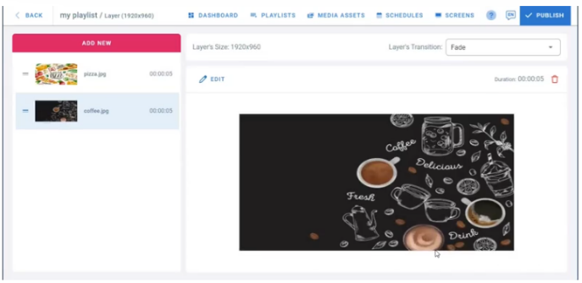Select images to add
* Wait for them to be uploaded. Once done, a green check will appear on the images
* Click on Done
* The images are added to the playlist

[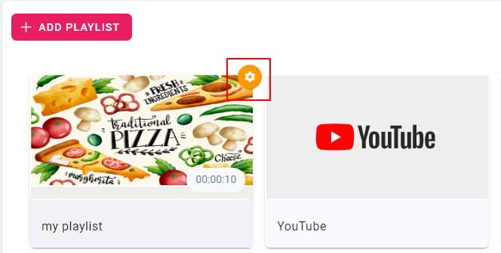](https://help.easysignage.com/assets/img/playlists/playlist_settings.jpg)Playlist Settings

* Go to the playlists page
* Hover on your playlist, you will see the settings button on the top right as shown in the image
* Click on it to open playlist settings
* [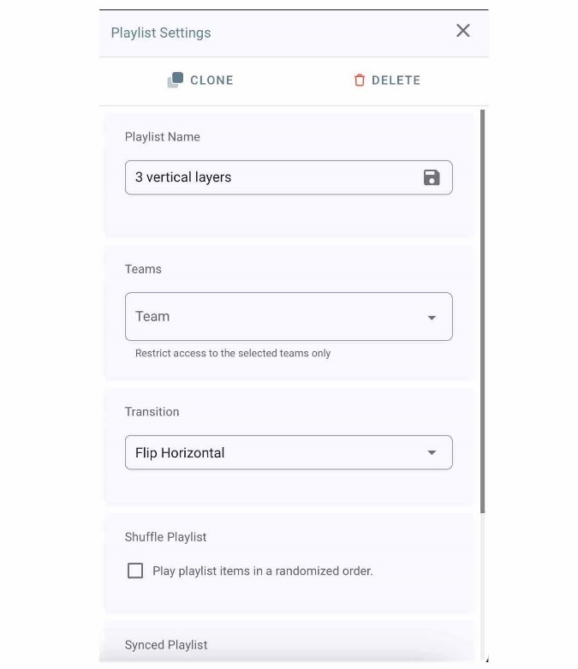](https://help.easysignage.com/assets/img/playlists/playlist_settings_open.jpg)**Clone**: To Clone a playlist with all its media and properties, click on **Clone**. Check the playlists, the newly cloned playlist will be there.
* **Delete**: Click on **Delete**, then click on Yes to confirm deleting the playlist
* **Playlist Name**: type in the playlist name, it will auto-save
* **Teams**: Restrict access to the selected teams only
* **Transition**: To change the playlist transition type, choose one from the drop down.  
  It will be applied to all the media under all the layers.  
  *Check your screen for preview, this is similar to a slideshow’s transition from a media to another.*
* **Shuffle Playlist**: check this box to play the playlist item in a randomized order.
* **Synced playlist**: Check this box if you want all your screens to play the same media at the same time.  
  If the playlist has multiple layers, only the last layer (last from top to base) will be synced. *This feature is for syncing a background layer between multiple screens.*
* To close the settings, click on the **X** button in the top right corner.

[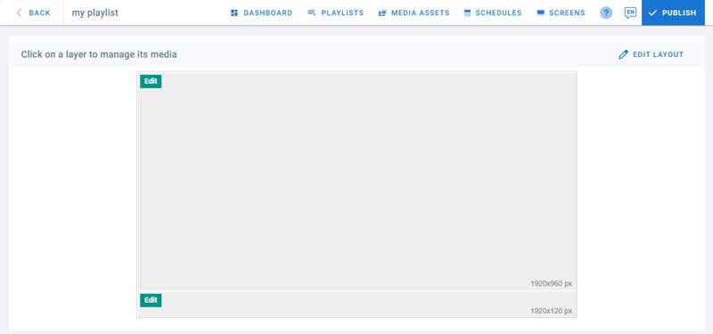](https://help.easysignage.com/assets/img/playlists/media_management.jpg)Playlist Media Management

* Open an existing playlist or create a new one
* From the layout preview, click on one of the layers to start adding content
* [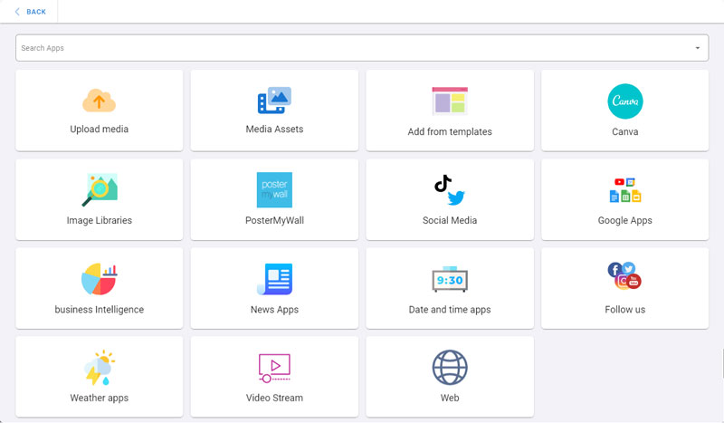](https://help.easysignage.com/assets/img/playlists/apps.jpg)Each layer has its own media apps depending on its size (width and height)
* If the layer is empty, the Apps dialog will open
* Click on an app to add it to the layer playlist

Layer’s Transition

* [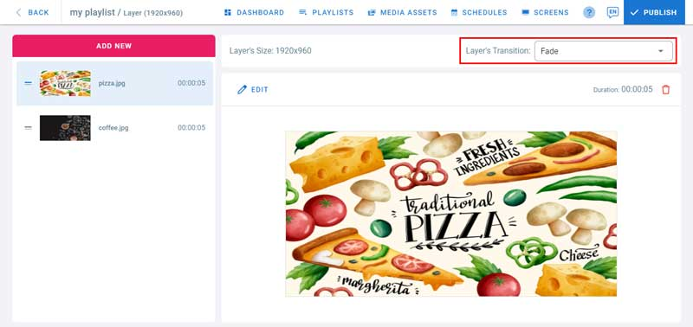](https://help.easysignage.com/assets/img/playlists/layer_transition.jpg)To change the transition type, choose one from the drop down.
* Layer transition will override playlist transition  
  *Check your screen for preview, this is similar to a slideshow’s transition from a media to another.*

 Add New

* [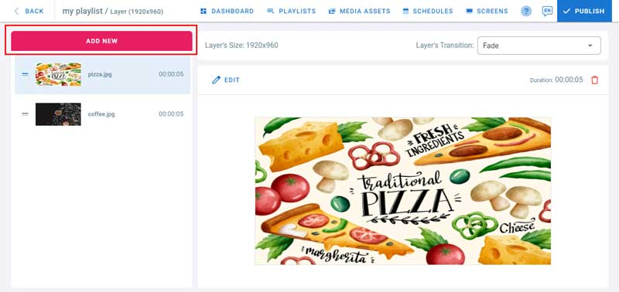](https://help.easysignage.com/assets/img/playlists/add_new.jpg)To add more content to the layer, click on the **Add New** button. Choose an app from the list.
* Below the Add New button are listed all the media items added to this layer
* Each media is represented by a preview, a name and the duration of playback
* **Order**: Drag and drop an item from the list to change its position in the layer playlist. This is the order of playback on the screen
* In the middle of the screen, you can preview the media item selected from the list
* **Edit**: Click on Edit on the top left corner of the media preview to manage media playback options. You can also hover the media item in the list and click on Edit.
* **Delete**: click on the delete icon on the top right of the preview to remove this media from the layer

Media Settings

* [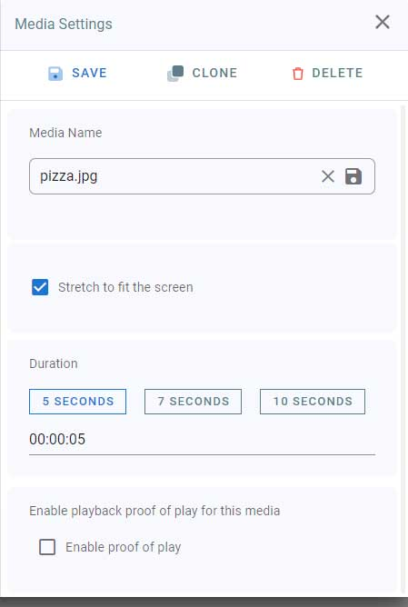](https://help.easysignage.com/assets/img/playlists/media_settings.jpg)**Media Name**: The media name can be used in Statistics collection. Type in a name for your media
* **Stretch to fit**: Check this box if you want your media (image or video) to fit the whole layer size without respecting the width to height ratio. If you want your media to be displayed with its original size irrespective to the layer size uncheck it.
* **Duration**: Choose your media playback duration in the layer playlist. Click on 5, 7 or 10 seconds, or, enter a value manually. 00:00:05 means 0 hours, 0 minutes and 5 seconds.
* **Save**: Click on Save to save your media settings.
* **Clone**: Click on clone to clone the media with all its properties.
* **Delete**: You can delete the media from here as well.
* To close the settings, click on the **X** button in the top right corner.

**Proof of Play**

[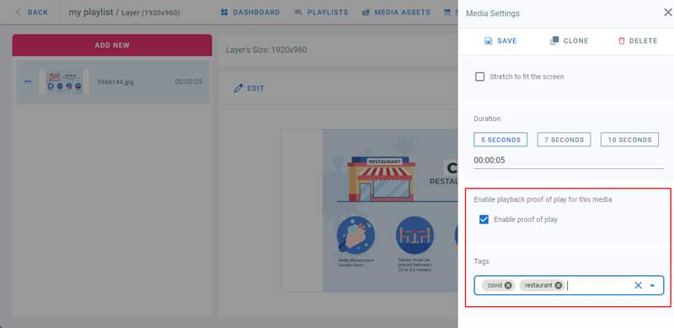](https://help.easysignage.com/assets/img/proof_of_play/proof_of_play.jpg)

* Proof of play is used for collecting playback statistics. Check this box to enable statistics collection when this media is played back
* Type in tags and Press Enter. This will help filtering the proof of play results
* To delete a tag, click on the x button next to its name, or on the X button at the right to delete all the tags

[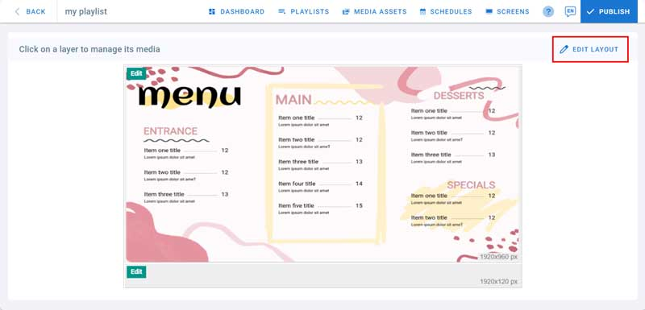](https://help.easysignage.com/assets/img/edit_layout/edit_layout.jpg)Layout Customization

* Go to playlists page
* Click on a playlist to open the layout view
* A layout is devided into layers
* In the below example, this layout has 2 layers: 1920x960 layer and 1920x120 layer
* [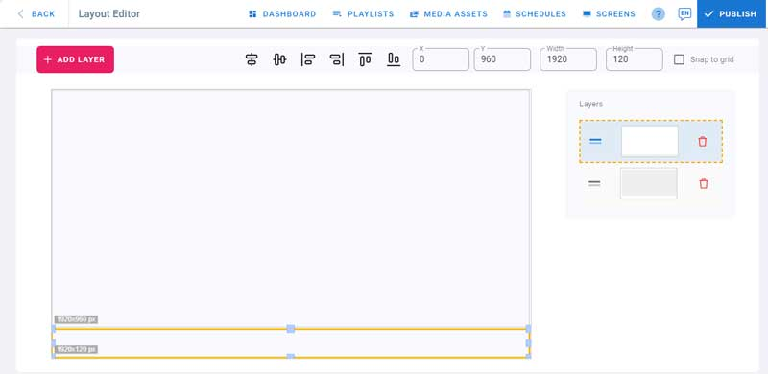](https://help.easysignage.com/assets/img/edit_layout/layout_editor.jpg)To customize your layout, click on **Edit Layout**

 Add Layer

* To add more layers to your layout, Click on **Add Layer**
* A maximum of **6 layers** is allowed in each layout. The layers can be placed on top of each other and support transparency in the content

Position

[Position](https://help.easysignage.com/assets/img/edit_layout/position.jpg)

* Click on a layer to select it or click on it in the list on the right
* Drag and Drop a layer to change its position in the layout, or, change X and Y values at the top
* **Snap to Grid**: if checked, instead of freely moving the layer pixel by pixel, it will move by 45 pixels horizontally and vertically

 Width and Height

* To resize a layer, drag and drop the resize controls
* Or provide a value in the width and height fields

[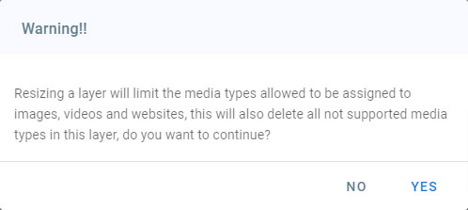](https://help.easysignage.com/assets/img/edit_layout/resize_warning.jpg)**Important**: when resizing you will get a warning about the content types you can use, not all media content can be used in custom sized layers:

[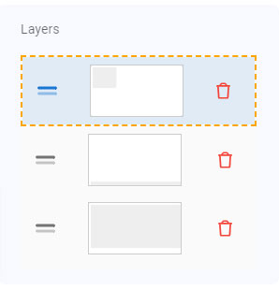](https://help.easysignage.com/assets/img/edit_layout/layer_list.jpg)

**Layer Order**: to change the order of a layer:

drag and drop it **up** in the list to bring to front

* drag and drop it **down** in the list to send to back
* **Delete**: Click on the delete button in the layers list and click yes to confirm deleting

All the content of the deleted layer will be removed.